NIMISHA JAMES

S2(R)MCA, ROLL NO:11

1.create table countries(country_id char(2),country_name varchar(20),region_id int(10));

insert into countries values('CA','Canada',2);

insert into countries values('DE','Germany',1);

insert into countries values('UK','United Kingdom',1);

insert into countries values('US','United States',2);

select * from countries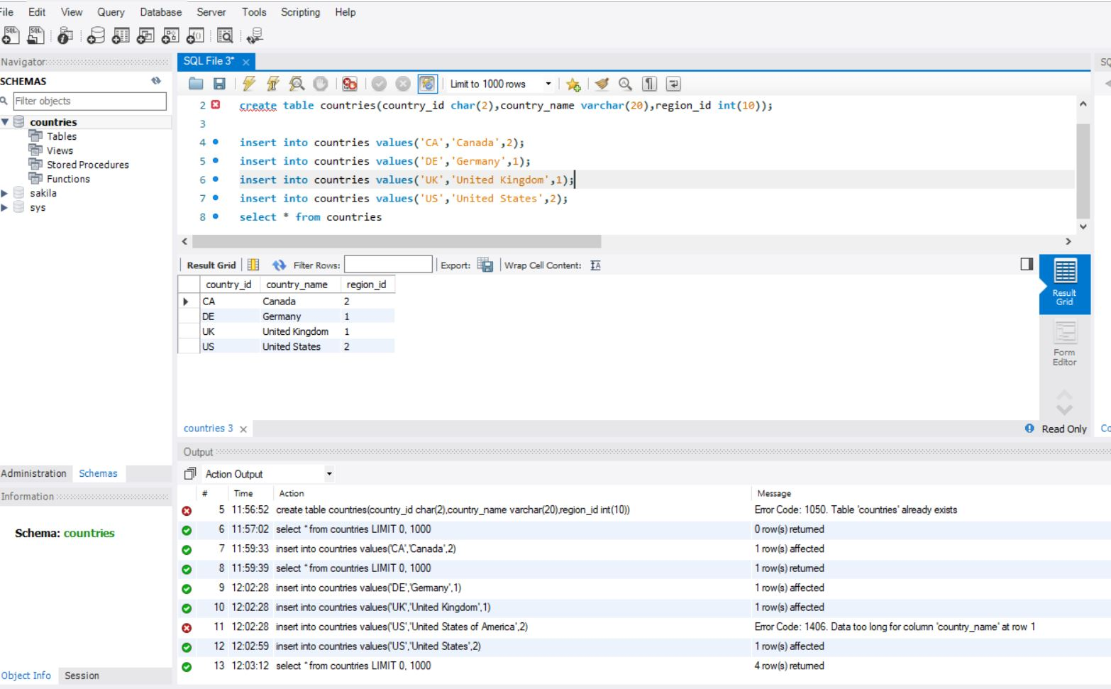

2.

create table departments(department_id numeric(4)NOT NULL,department_name varchar(30)NOT NULL,manager_id numeric(6),location_id numeric(4));

insert into departments values(10,'Administration',200,1700);

insert into departments values(20,'marketing',201,1800);

insert into departments values(50,'shipping',124,1500);

insert into departments values(60,'IT',103,1400);

insert into departments values(80,'sales',149,2500);

insert into departments values(90,'Executive',100,1700);

insert into departments values(110,'Accounting',205,1700);

insert into departments values('190','Coutracting',0,1700);

select * from departments

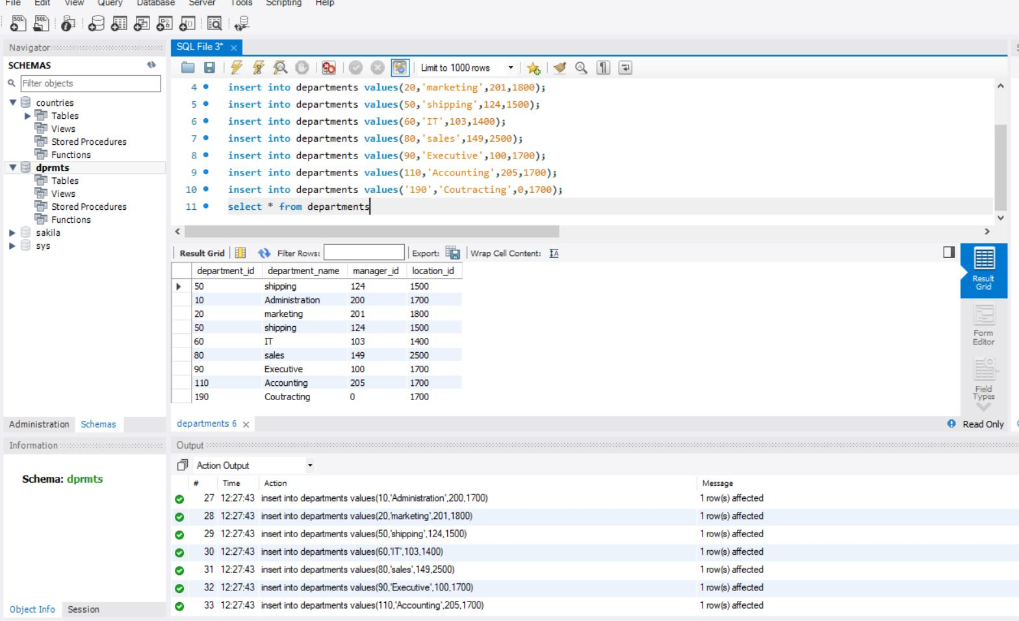

3.

create table employees(employee_id numeric(6)NOT NULL,first_name varchar(20),last_name varchar(25),email varchar(25),phone_numer varchar(25),hire_date date,job_id varchar(10),salary numeric(8,2),commission_pct numeric(2,2),manager decimal(6),department_id decimal(4));

insert into employees values (100,'steven','king','sking','515.123.4567','1987-06-17','ad_pres',24000,NULL,NULL,90);

insert into employees values (101,'neena','kochhar','kochhar','515.123.4568','1989-09-21','ad_vp',24000,NULL,100,90);

insert into employees values (102,'lex','de haan','ldehaan','515.123.4569','1993-01-13','ad_vp',17000,NULL,100,90);

insert into employees values (103,'alexander','hunold','ahunold','590.423.4567','1990-01-03','it_prog',9000,NULL,102,60);

insert into employees values (104,'bruce','ernst','bernst','590.423.4568','1991-05-21','it_prog',6000,NULL,103,60);

insert into employees values (107,'diana','lorentz','dlorentz','590.423.5567','1999-02-07','it_prog',4200,NULL,103,60);

insert into employees values (124,'kevin','mourgos','kmourgos','650.123.5234','1999-11-16','st_man',5800,NULL,100,50);

insert into employees values (141,'trenaa','rajs','trajs','650.121.8009','1995-10-17','st_clerk',3500,NULL,124,50);

insert into employees values (142,'curtis','davies','cdavies','650.121.2994','1997-01-29','st_clerk',3100,NULL,124,50);

insert into employees values (143,'randall','matos','rmatos','605.121.2874','1998-03-15','st_clerk',2600,NULL,124,50);

insert into employees values (144,'peter','vargas','pvargas','605.121.2004','1998-07-09','st_clerk',2500,NULL,124,50);

insert into employees values (149,'eleni','zlotkay','ezlotkay','011.44.1344.429018','2000-01-29','sa_man',10500,.2,100,80);

insert into employees values (174,'ellen','abel','eabel','011.44.1644.429267','1996-05-11','sa_rep',11000,.3,149,80);

insert into employees values (176,'jonathon','tylor','jtylor','011.44.1644.429265','1998-03-24','sa_rep',8600,.2,149,80);

insert into employees values (178,'kimberely','grant','kgrant','011.44.1644.429263','1999-05-24','sa_rep',7000,.15,149,NULL);

insert into employees values (200,'jennifer','whalen','jwhalen','515.123.4444','1987-09-17','ad_asst',4400,NULL,101,10);

insert into employees values (201,'michael','hartstein','mhartstein','515.123.5555','1996-02-17','mk-man',13000,NULL,100,20);

insert into employees values (202,'pat','fay','pfay','603.123.6666','1997-08-17','mk_rep',6000,NULL,201,20);

insert into employees values (205,'shelley','higgins','shiggins','515.123.8080','1994-06-07','ac_mgr',12000,NULL,101,110);

insert into employees values (206,'william','gietz','wgietz','515.123.8181','1994-06-07','ac_account',8300,NULL,205,110);

select * from employees;

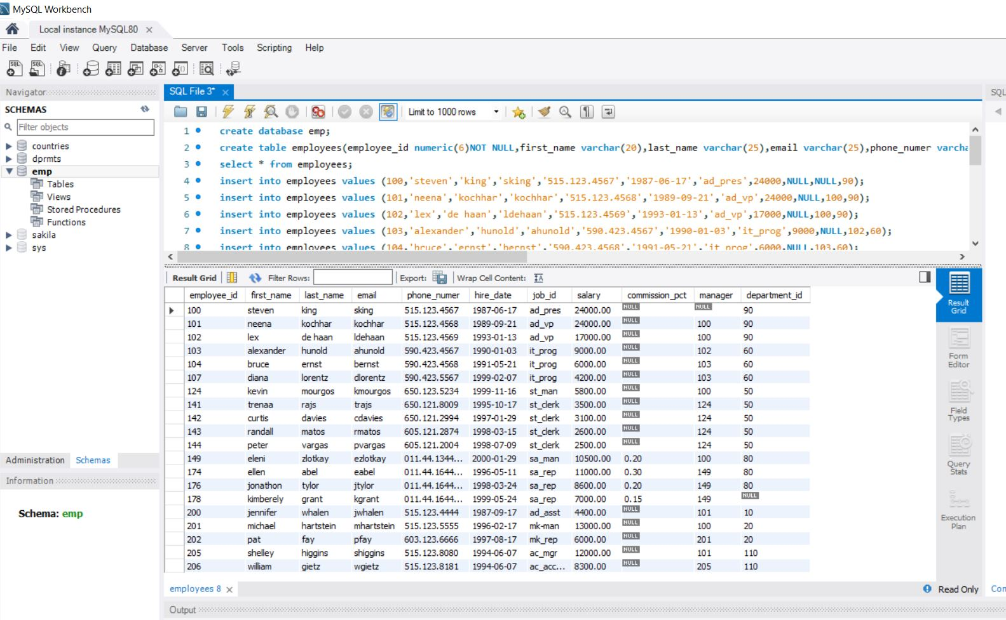

4. CREATE TABLE jobs (JOB_ID varchar(10) NOT NULL, JOB_TITLE varchar(35) NOT NULL, MIN_SALARY decimal(6), MAX_SALARY decimal(6),PRIMARY KEY (JOB_ID));

INSERT INTO jobs VALUES ('AD_PRES','President',20000,40000),('AD_VP','Administration Vice President',15000,30000),('AD_ASST','Administration Assistant',3000,6000),('AC_MGR','Accounting Manager',8200,16000),('AC_ACCOUNT','Public Accountant',4200,9000),('SA_MAN','Sales Manager',10000,20000),('SA_REP','Sales Representatives',6000,12000),('ST_MAN','Stock Manager',5500,8500),('ST_CLERK','Stock Clerk',2000,5000),('IT_PROG','Programmer',4000,10000),('MK_MAN','Marketing Manager',9000,15000),('MK_REP','Marketing Representative',4000,9000);

Select * from jobs

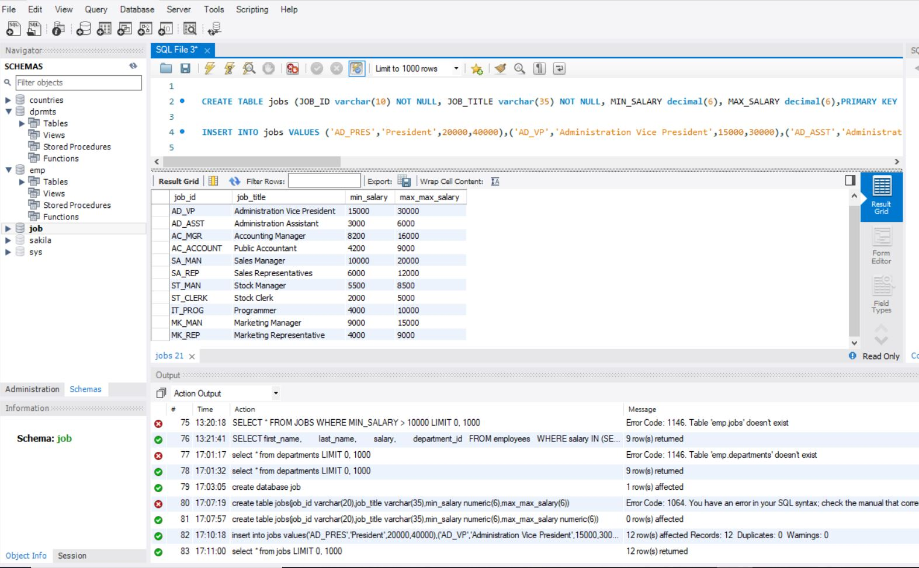

5.CREATE TABLE job_grades (gradelevel varchar(3),lowest_sal decimal,highest_sal decimal(8,2));

INSERT INTO job_grades VALUES ('A',1000,2999),('B',3000,5999),('C',6000,9999),('D',10000,14999),('E',15000,24999),('F',25000,40000);

select * from job_grades;

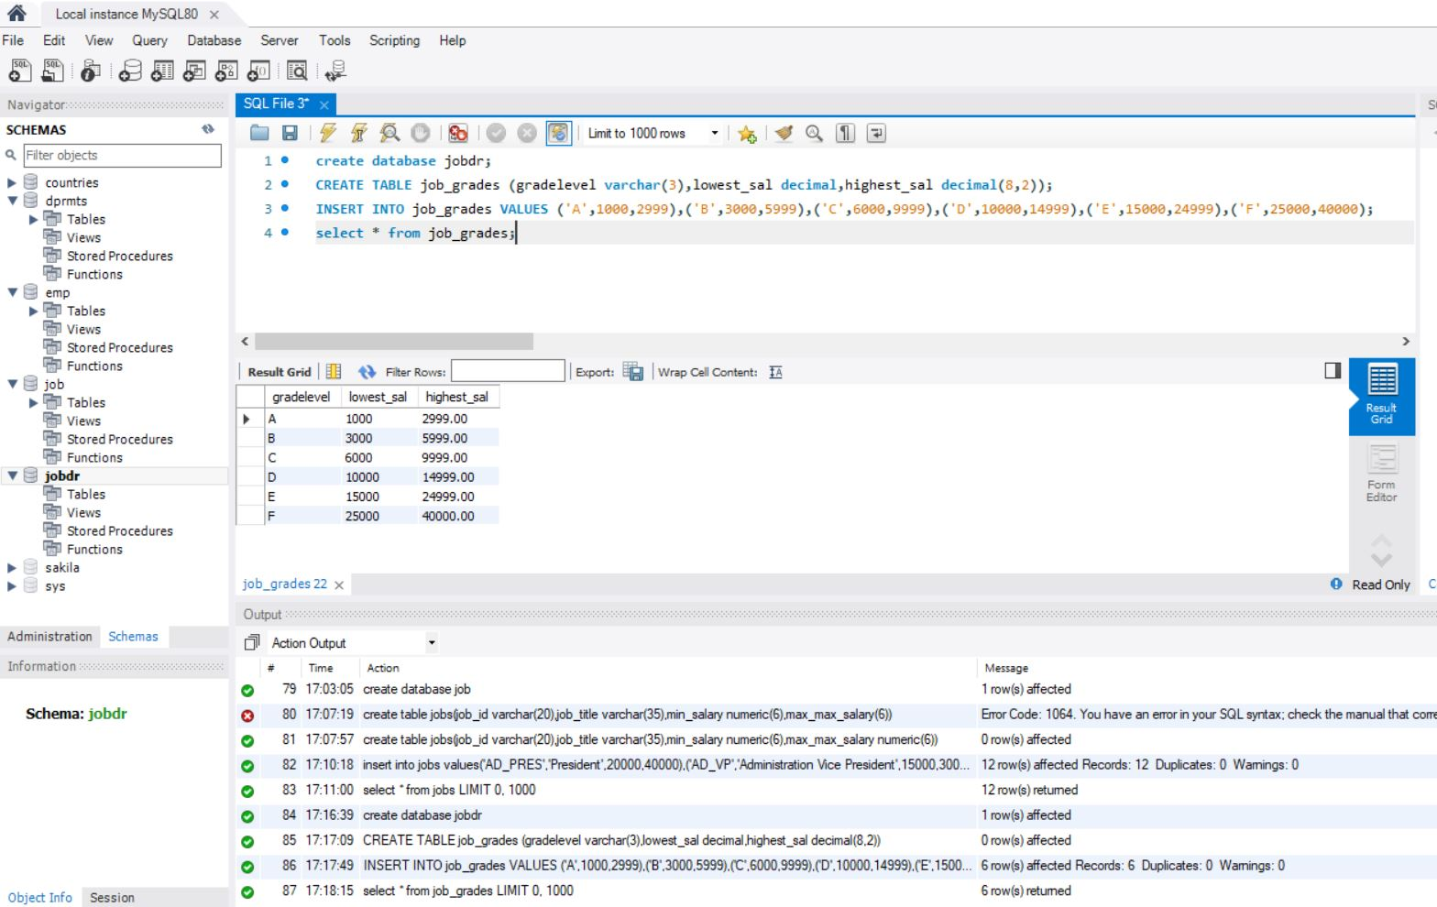

6. CREATE TABLE job_history ( EMPLOYEE_ID decimal(6,0) NOT NULL PRIMARY KEY, START_DATE date NOT NULL, END_DATE date NOT NULL, JOB_ID varchar(10) NOT NULL, DEPARTMENT_ID decimal(4,0));

INSERT INTO job_history VALUES (102,'1993-01-13','1998-07-24','IT_PROG',60),(101,'1989-09-21','1993-10-27','AC_ACCOUNT',110);

select * from job_history

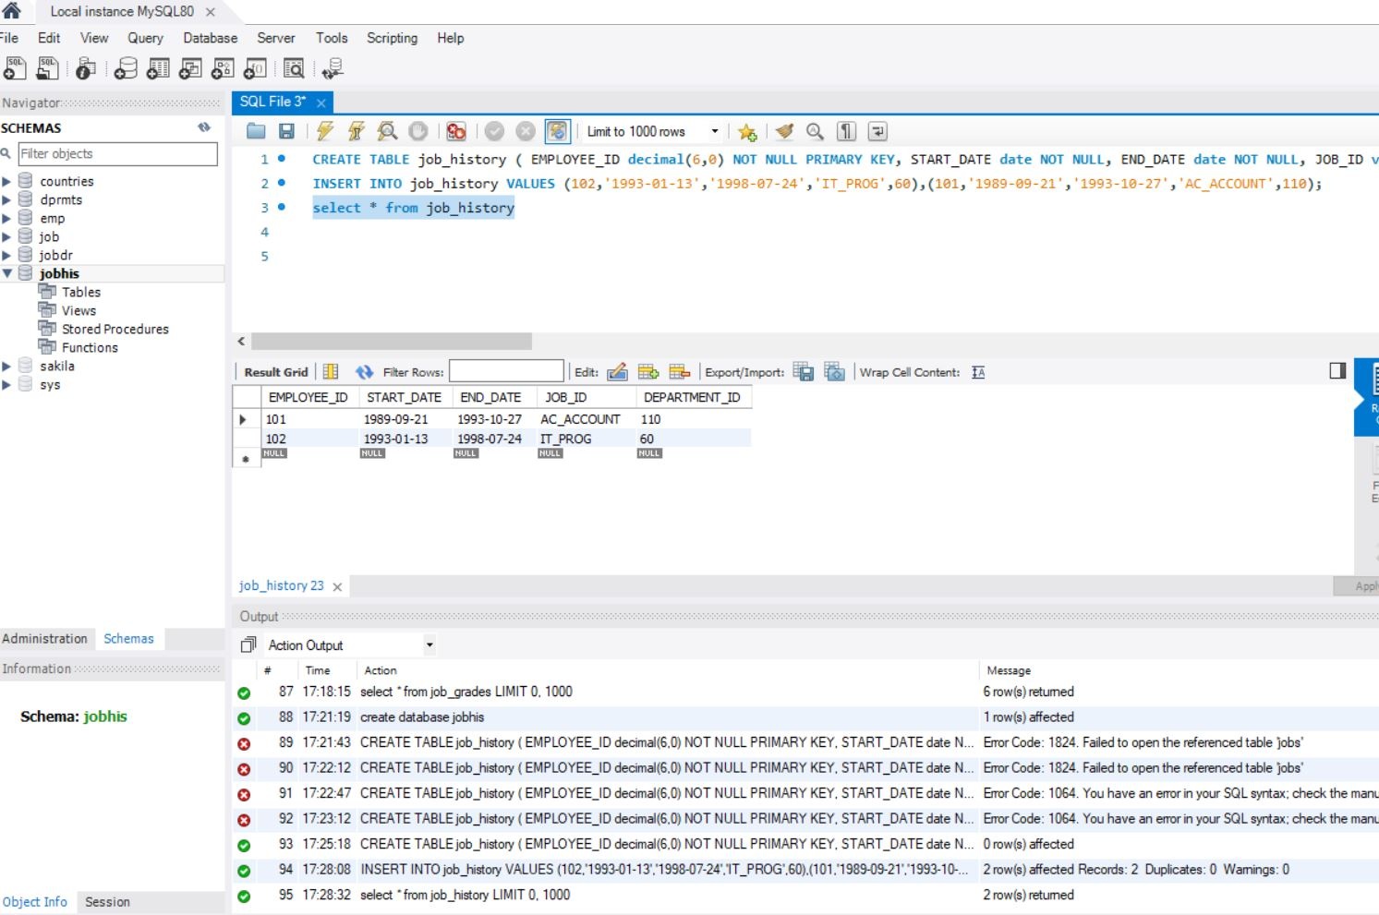

7.CREATE TABLE locations (LOCATION_ID decimal(4) NOT NULL, STREET_ADDRESS varchar(40), POSTAL_CODE varchar(12), CITY varchar(30), STATE_PROVINCE varchar(25) NOT NULL, COUNTRY_ID char(2), PRIMARY KEY (LOCATION_ID));

INSERT into locations values(1500,'2011inteririosRd',99236,'south san franscisco','california','US'),(1400,'2014 jacabberwocky Rd',26192,'sothlake','texas','US'),(1700,'2004 Charade Rd',98199,'seattle','washington','US');

select * from locations

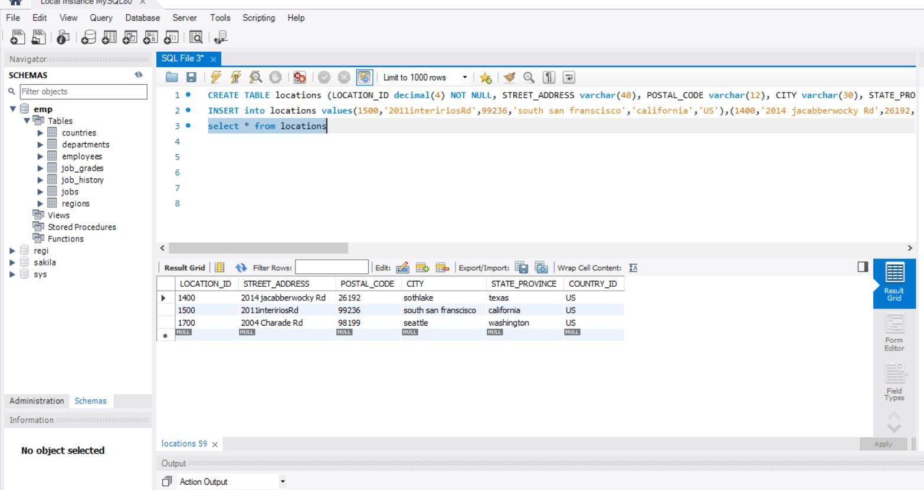

8.CREATE TABLE regions (region_id DECIMAL,region_name VARCHAR(25));

INSERT INTO regions VALUES (1,'EUROPE'),(2,'AMERICA'),(3,'ASIA'),(4,'MIDDLE EAST AND AFRICA');

select * from regions

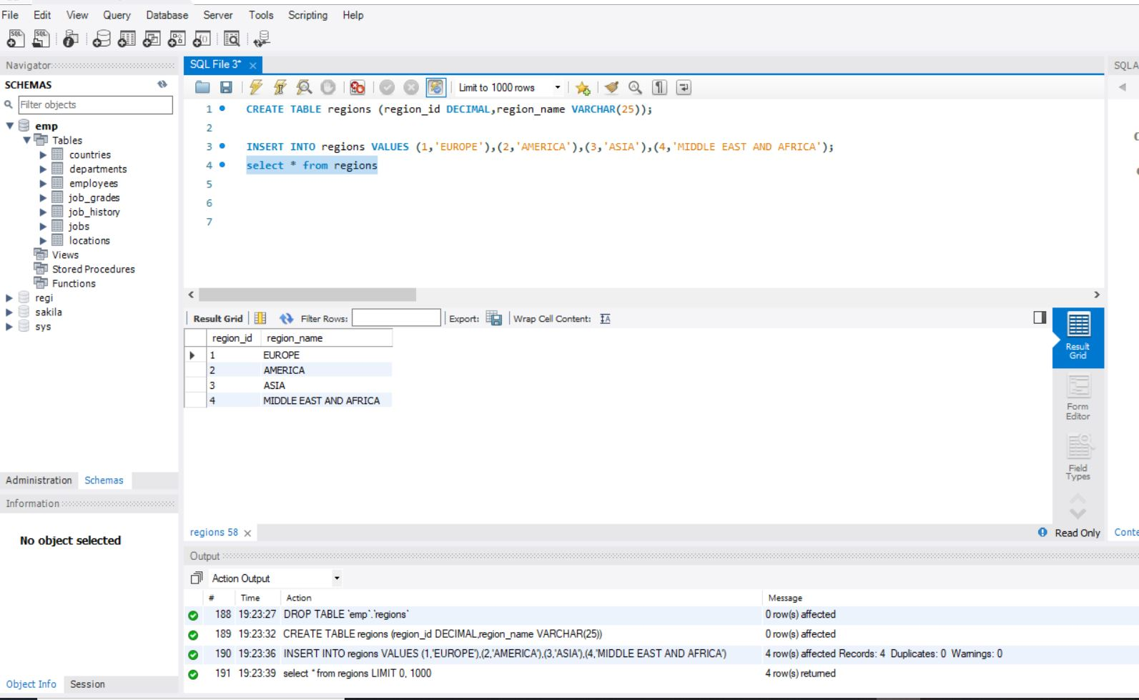

1.SELECT *

FROM employees

WHERE job_id = 'ST_CLREK'

AND hire_date > '1997-12-31';

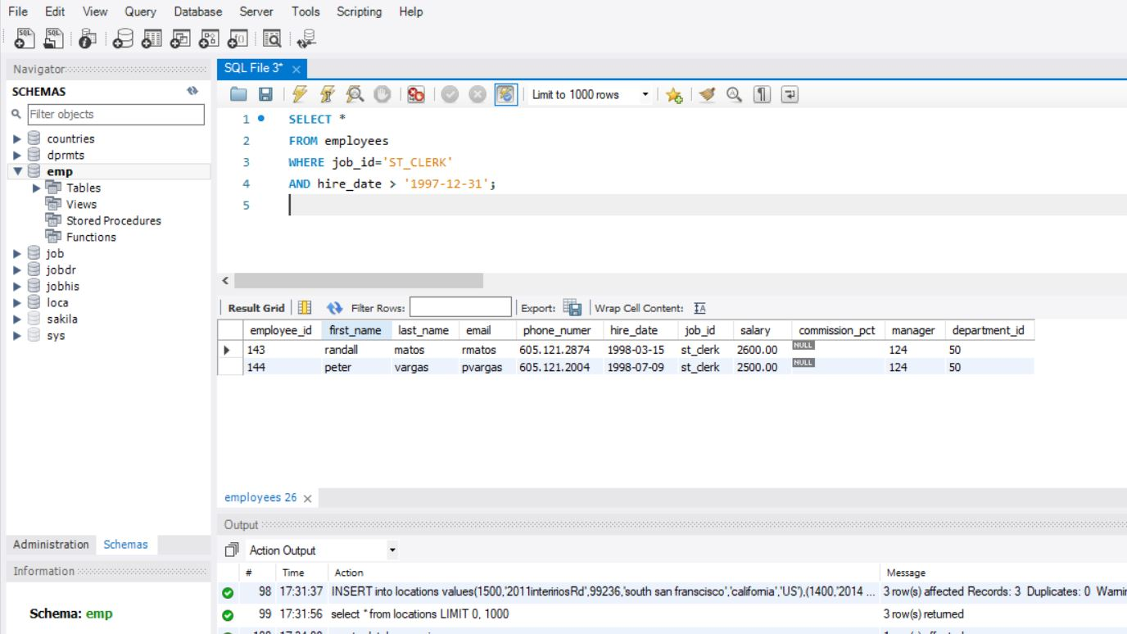

2. SELECT last_name,job_id,salary,commission_pct

FROM employees

WHERE commission_pct IS NOT NULL

ORDER BY salary DESC;

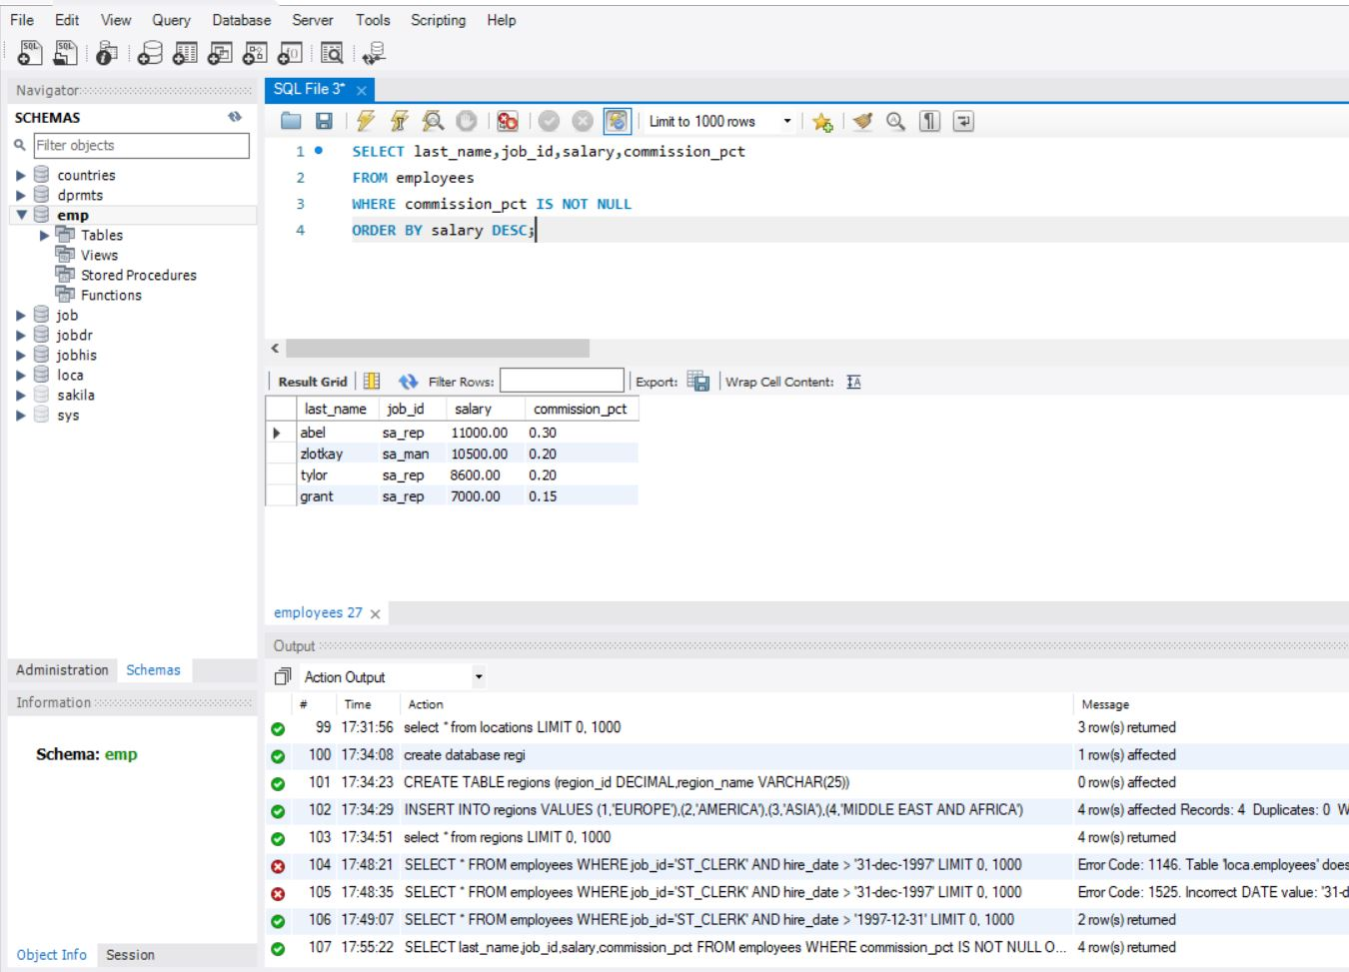

3. SELECT 'The salary of '||last_name||' after a 10% raise is '

|| ROUND(salary*1.10) "New salary"

FROM employees

WHERE commission_pct IS NULL;

4. SELECT last_name,

TRUNC(MONTHS_BETWEEN(SYSDATE, hire_date) / 12) YEARS,

TRUNC(MOD(MONTHS_BETWEEN(SYSDATE, hire_date), 12))

MONTHS

FROM employees

ORDER BY years DESC, MONTHS desc;

5. SELECT last_name FROM employees WHERE SUBSTR(last_name, 1,1) IN ('J', 'K', 'L', 'M');

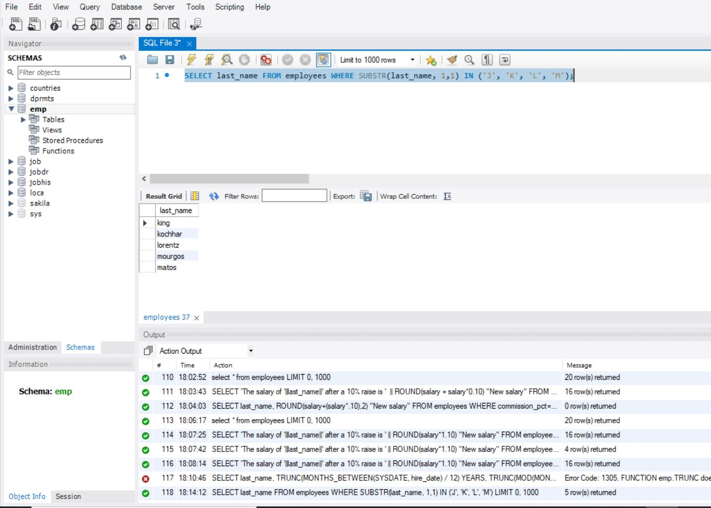

6. SELECT d.department_name, d.location_id, e.last_name,

e.job_id, e.salary

FROM employees e, departments d

WHERE e.department_id = d.department_id

AND d.location_id = location_id;

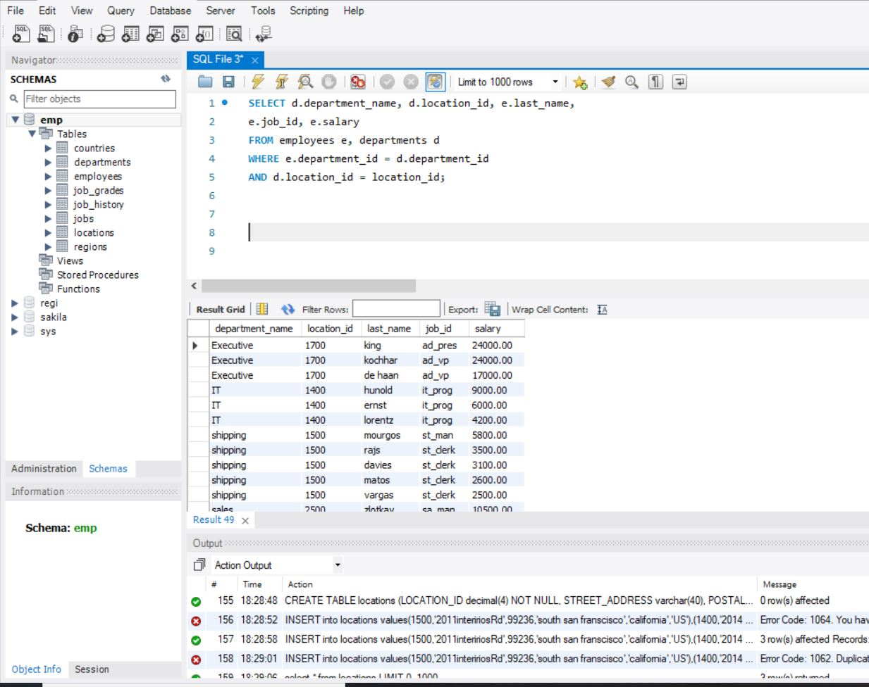

7. SELECT count(*)

FROM employees

WHERE last_name LIKE '%n';

